

**SOCIAL STUDIES**

**SHOUT OUT pg.2**

**WEDNESDAY WORDS**

**PLANNER UPDATE:** Record important

assignment information in your planner.

**DRESS TO IMPRESS**: Earn lottery tickets for

dressing up on Wednesdays.

**WATCH CNN STUDENT NEWS**

**VOCABULARY WORD WALL:** Check out unfamiliar words listed on the word wall to discover their meanings.

**THURSDAY TRIVIA**

**PLANNER UPDATE:** Record important

assignment information in your planner.

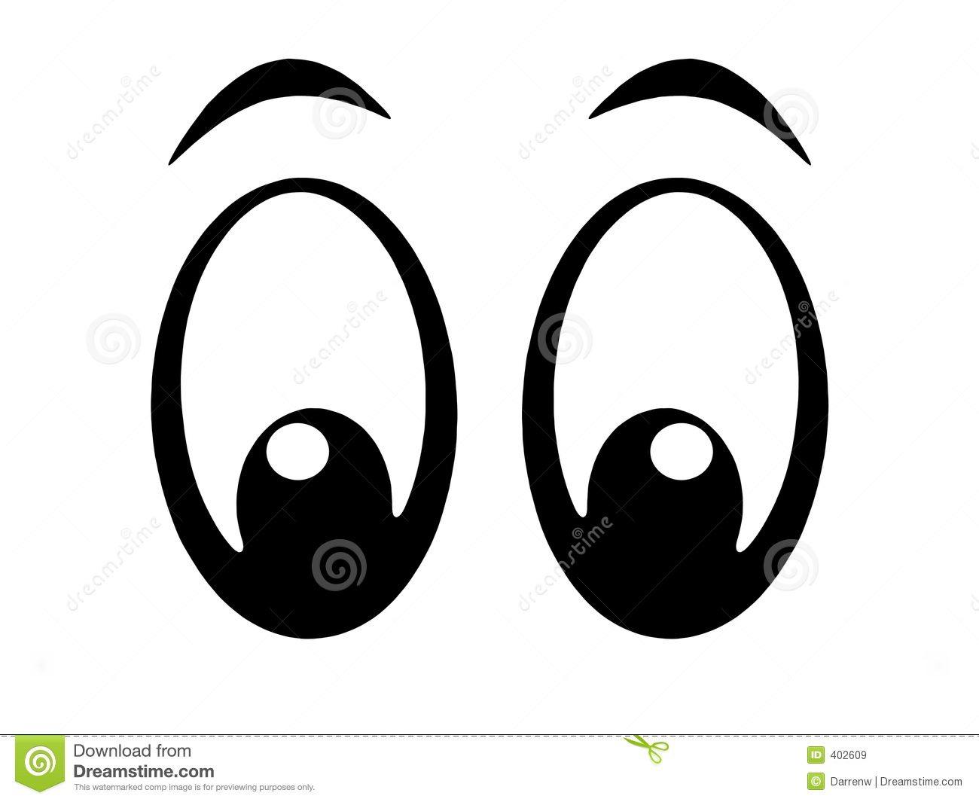

**TRIVIA:** Record your answer to the trivia found on the whiteboard below.

**FINISH-UP FRIDAY**



**SUMMARY:** Answer each section below by choosing one story to

summarize using your notes on front.

1. What is the news story about? Who is involved and why did it happen?

____________________________________________

____________________________________________

____________________________________________

____________________________________________

2. When did it happen?**_______________________**

3. Where did it happen?_________________________

4. How is this story affecting the world or people?

____________________________________________

____________________________________________

5. How do you feel about this story and why?

____________________________________________

____________________________________________

6. Circle any of these this story is connected to:

Geography/Environment Personal Opinion

Groups of People World Conflict

Invention/Discovery History

Goods & Services/Economy Government

**Weekly Wrap Up:** Teacher choice of catch-up time, whole class Junior Scholastic reading, Quiz Bowl and/or journal updates.

**PANTHER PRIDE**: Earn lottery tickets for

wearing green and gold on Fridays.

**TURN in this SHOUT OUT SHEET for a grade!**

**PLANNER UPDATE:** Record important

assignment information in your planner.



**WATCH CNN STUDENT NEWS**

**WATCH CNN STUDENT NEWS**



**____________________________________________**

**____________________________________________**

**____________________________________________**

**____________________________________________**

**____________________________________________**

**____________________________________________**

**____________________________________________**

**____________________________________________**

Directions: Record the vocabulary word in the middle of the triangle. Record three connections to the word on the sides of the triangle.