

**SOCIAL STUDIES**

**SHOUT OUT**

Follow the tasks in the order they are listed each day on this Soc. St. Shout Out sheet. **Your Social Studies Shout Out sheet is collected every Friday for a grade**.

**Student News Highlights**

**Monday**

____________________________________________

____________________________________________

____________________________________________

____________________________________________

**Tuesday**

____________________________________________

____________________________________________

____________________________________________

____________________________________________

**Wednesday**

____________________________________________

____________________________________________

____________________________________________

____________________________________________

**Thursday**

____________________________________________

____________________________________________

____________________________________________

____________________________________________

**Friday**

____________________________________________

____________________________________________

____________________________________________

____________________________________________



**Directions:** Watch CNN Student news. In the space provided, take notes on stories that interest you.

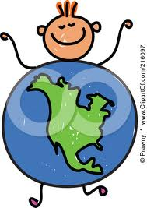

**____________________________________________**

**____________________________________________**

**____________________________________________**

**____________________________________________**

**____________________________________________**

**____________________________________________**

**____________________________________________**

**____________________________________________**

**WATCH CNN STUDENT NEWS**

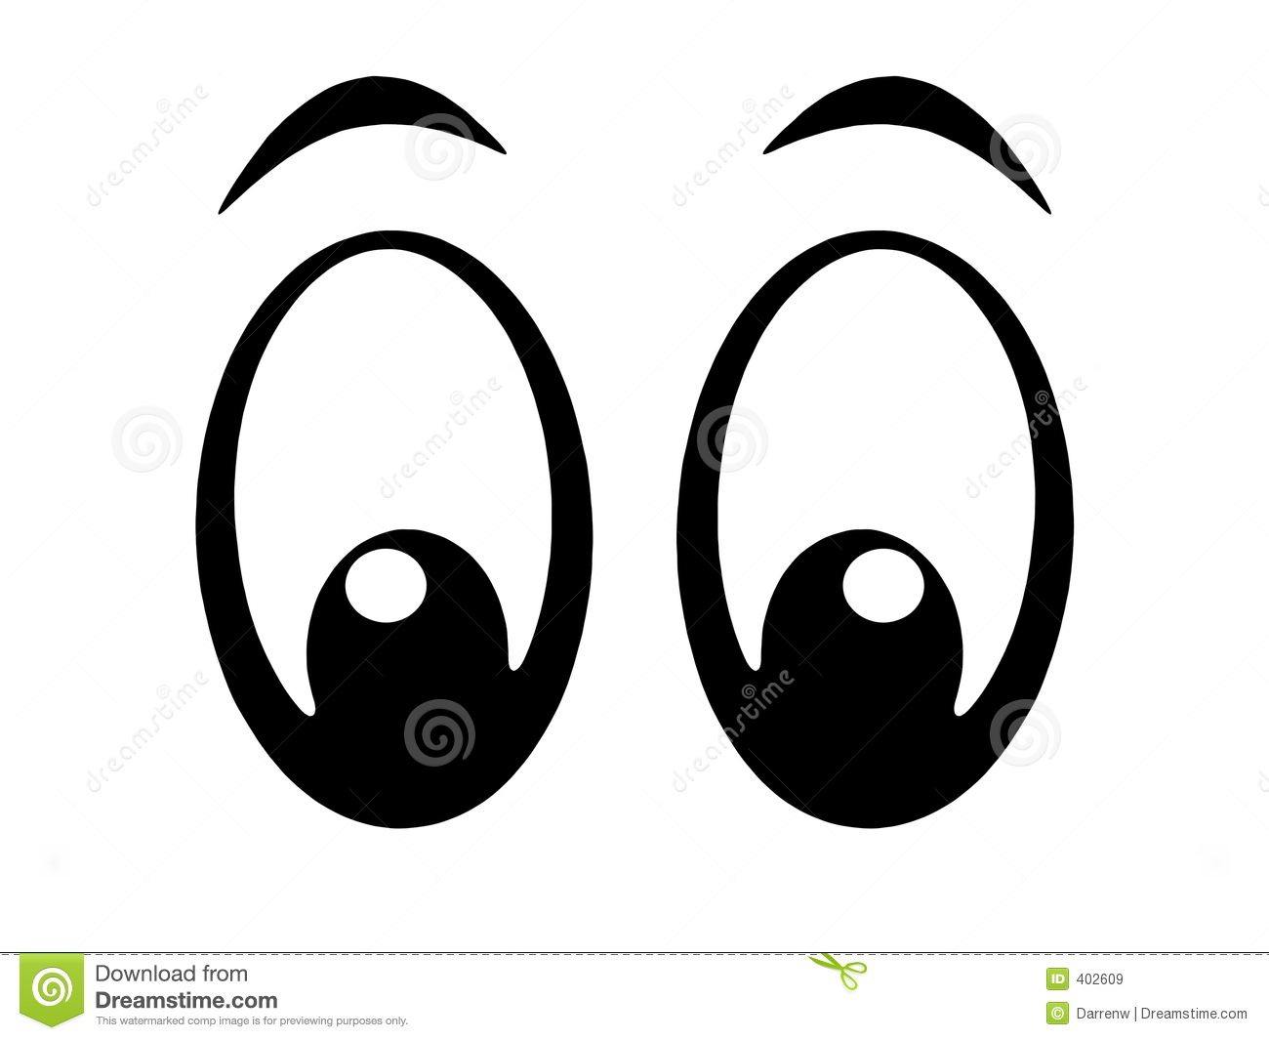

**MONDAY MADNESS**

**PLANNER UPDATE:** Record important

assignment information in your planner.

**A GREAT WEEK STARTS BY SHARING A…**

**GOOD THING:** _____________________________

_____________________________________________

**QUESTION of the WEEK:** __________________

_____________________________________________

**WATCH CNN STUDENT NEWS**

**TUESDAY TRIVIA**

**PLANNER UPDATE:** Record important

assignment information in your planner.



**TRIVIA:** Record your answer to the trivia found on the whiteboard below.

Directions: Record the vocabulary word in the middle of the triangle. Record three connections to the word on the sides of the triangle.